Web Design Document
Site Name:
Lifting Weights

Site Goal:
Provide historical info about weightlifting, suggest places where you can go to lift weights, inform about weightlifting equipment, supplements and how to gain muscle.

Audience:
Fitness enthusiasts: Individuals who are already active and motivated to maintain or improve their fitness.
Weight loss seekers: People looking to lose weight and improve overall health.
Athletes: Professional or amateur athletes needing specialized training and conditioning.
Our primary audience is men and women age 18-34.

Wireframes:
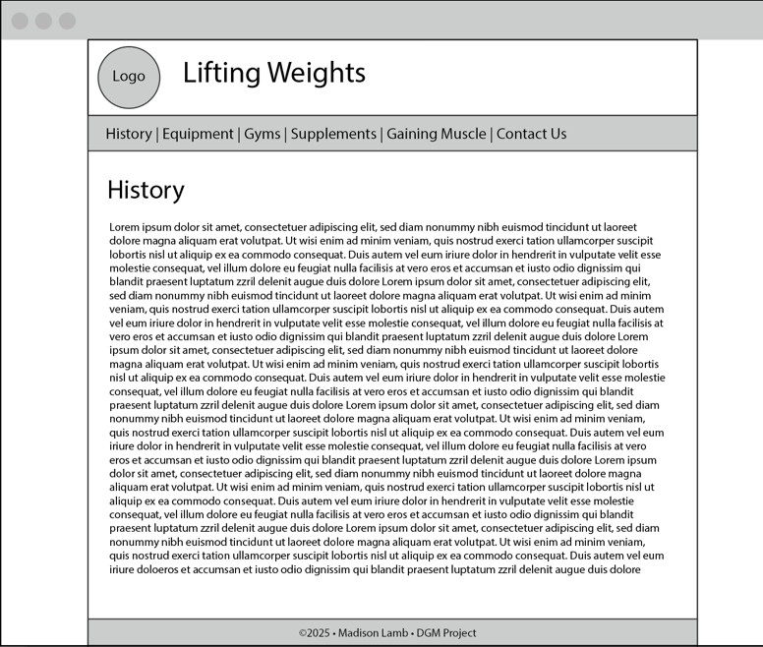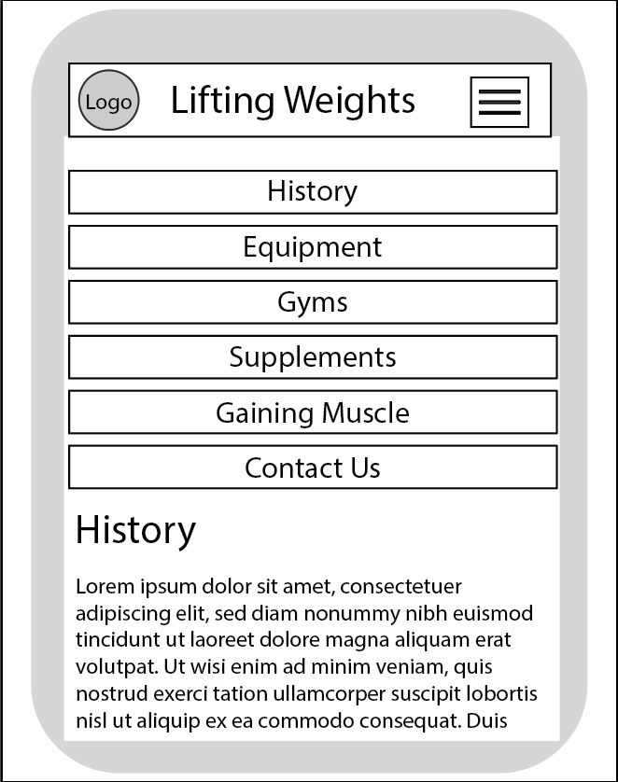

Site Map:
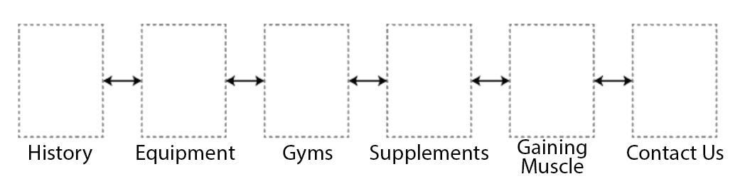

Font Family:


Color Scheme:
